Policy/Document: Marking/Feedback Policy
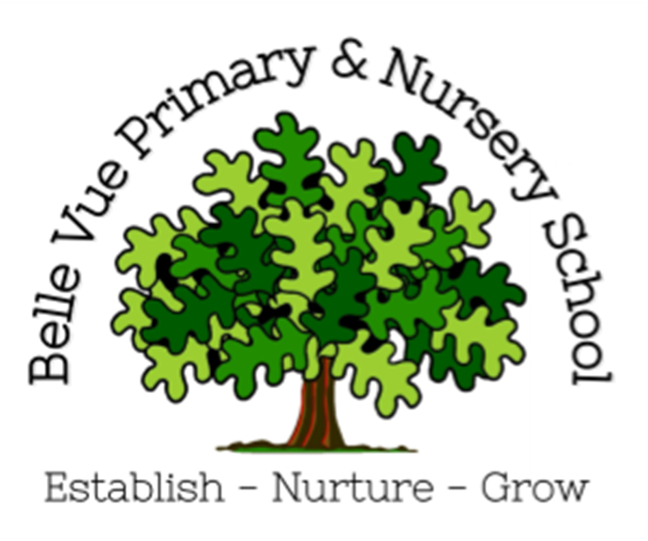
Date approved:March 2023
Changes made: Reviewed March 2023
July 2024: No changes
February 2025: pg 3 Verbal feeback to be documented on English and Maths marksheets; peer feedback definition added; Modes of feedback note on marksheets; Pg 4 VF changed to teacher initials. Expectations. Pg 5 English marking codes; All other subjects
May 2025:pg 3, added points to what does this look like, pg 4 Expectations; change in marksheets; pg 5 English feedback slides and spelling corrections, pg 6 omitted Appendix A and Appendix B added
September 2026: Policy Reviewed and following changes made: pg 3 removal of growth mindset language; pg 4 written feedback paragraph removal of VF written in book; page 5 additional paragraph added for presentation of work.
This policy was written in response to the questions, “Who are we marking for?” and “What are we marking for?”
The time taken to mark is not indicative of effective marking. Ofsted don't expect to see any specific frequency, type or volume of marking and feedback. However, marking/feedback should be consistent with the school assessment policy and promote pupil progress. Our policy is built on an agreed culture of high expectations and aspirations of all learners through effective feedback on children’s work.
Key principles of our policy
- The sole focus of feedback should be to further children’s progression through the curriculum.
- Evidence of feedback is incidental to the process; we do not provide additional evidence for external verification.
- Feedback should empower children to take ownership for improving their work; adults should not be doing the work for the pupil.
- Written comments should only be used as a last resort for the very few children who otherwise are unable to locate their own errors, even after guided modelling by the teacher.
- Children should receive feedback whether within the lesson itself or in the next appropriate lesson. The ‘next step’ is usually the next lesson.
- New knowledge is fragile and usually forgotten unless explicit steps are taken over time to revisit and refresh learning. Teachers should be wary of assuming the children have securely understood material based on evidence drawn close to the point of teaching it. Therefore, teachers will need to get feedback at some distance from the original teaching input when assessing if learning is now secure.
What is feedback?
Feedback is information provided by the teacher regarding aspects of one’s performance or understanding. It occurs typically after instruction that seeks to provide knowledge and skills or to develop particular attitudes. Feedback is among the most critical influences on student learning (Hattie & Timperley, 2007).
Our Philosophy
‘Real time’ feedback, given at the point of learning, is more effective than the children receiving written feedback after the lesson. This way, ‘response time’ is not needed as a bolt-on in the timetable. Children will respond to feedback in real-time, all the time, during their learning. At Belle Vue Primary School, we advocate active learning and adult interaction for all children in all lessons.

What does this look like in the classroom?
- Adults working the room continuously – looking/reacting/feeding back/live marking.
- Adults stopping to give precise intervention to individuals/groups/whole class.
- No children queuing to be seen by a ‘stationary’ teacher.
- No marking of books from other subjects to be done during lessons.
- No child waiting for feedback before they can move on.
Teachers at Belle Vue Primary School will give feedback as much as is possible/appropriate during the learning within a lesson. This may purely be verbal feedback, to either an individual, group or whole class, or may involve writing/marking on the child’s work.
Peer feedback is also encouraged. To be effective, peer assessment should encourage children to think about someone else’s work and consider how well it has achieved the learning goal for that lesson. It should also be used so that peers can identify areas of strength in others’ work and also areas in which improvements could be made.
Feedback should be centred on the success criteria for the learning at the time, however teachers should use their judgement to feedback on other areas related to learning.
This way, teachers should know during the lesson, who is mastering the learning objective and who needs more support, and can adapt the lesson as appropriate in real time rather than waiting to mark books after the lesson.
Modes of feedback at Belle Vue Primary School
The following are different modes of feedback used – the frequency of each type will depend upon the age and development of each child.
- Verbal feedback to an individual child: Teachers and Teaching Assistants should be constantly giving verbal feedback to individuals throughout learning time. This could be very brief or it could be more in-depth. Brief feedback does not need to be recorded – it is evident all the time during teaching. More in-depth individual feedback – for example using Numicon to demonstrate a concept with a child – can be recorded on whole-class marksheets (where applicable). There is no need to record the details of the feedback given – the evidence is seen from the improvement in the child’s work. Sometimes during verbal feedback, the teacher will write a word or phrase to remind the children of the discussion e.g. adverbs. It is not expected for teachers to write ‘remember to use more adverbs in your writing’.
The word on its own is enough to remind the child/children. In some situations, e.g. maths, the teacher may use their pen to model a calculation or draw a diagram to explain a concept as they talk to the child. It is best to model in a child’s book when feeding back one-on-one, rather than on a whiteboard, as this way the child will have a reminder of the feedback to support them.

- Verbal feedback to a group of children: Teachers may speak to a whole group – mixed or grouped according to their prior attainment – to give them feedback as a whole. This may include demonstration or modelling a concept. Brief feedback does not need to be recorded, but more focussed time with a group should be demarcated using staff initials next to the work.

- Verbal feedback to a whole class: This could include, for example, discussion of solutions to an open-ended maths investigation. There is no need for the teacher to record this on the child’s work. It could also include giving the answers to a times table or spelling quiz, this could be peer or self-marked.

- Written feedback about children’s work: The vast majority of written feedback is not written in children’s books. Feedback on children’s work is vital to ensuring that their next steps in learning are known. This allows the teacher to plan the next piece of learning in the sequence and for all pupils to understand what they have done well and what needs to be improved. Our approach to written feedback is similar for each subject, which reduces the amount of time “marking” but maximises further learning opportunities through feedback. Written marking should be brief and completed in conjunction with verbal feedback. Staff will use green pen to acknowledge what they have done well and purple pen for improvement.
Expectations
Whilst looking through books, teachers make notes on the key messages to feedback to pupils at the start of the next lesson. Teachers will record in a child’s book or on a whole-class mark sheet, if the pupil has received support during the lesson. Mark sheets and feedback records help to inform future planning and are a quick way of identifying next steps in pupil progress. Next steps may be specific to a child, small group or whole class. There are specific formats for Maths and English.
- Maths:
Whole class Mark Sheets (see Appendix A) are completed after the lesson has taken place, to reflect upon the teaching and learning. Staff complete these so they have an overview of the learning and lesson and a record of the assessment for learning that has taken place. Key vocabulary, good examples, misconceptions and any additional support required/given is recorded on a whole class marking sheet and the purpose of the feedback sheet is to ensure staff can suitably plan for the next lesson and adapt as necessary to meet the needs/misconceptions identified.
- English:
Feedback and assessment lesson slide(s) – these are used to reflect on the learning during a lesson and the written work produced. Once teachers have read through each pupils’ work from a lesson, they will make notes on key issues/errors that are common across the class. These will then be shared with the children at the start of the next lesson, so that they can address them and make any necessary corrections. Once having seen all work, a teacher may decide that a child requires more personal and individual feedback and support. If this is the case, they will work with the child during the next lesson or at an alternative time (e.g. assembly time). The feedback slide(s) provide a comprehensive assessment of the lesson and allows the children to be given clear next steps in their learning. Working alongside this are marking codes (see appendix) that children will see in their books. These codes are they to inform children of word/sentence/spelling/punctuation errors they have made in their written work.

- All other subjects:
Teachers will look at all work produced by the children and they will indicate where the children have understood the task or where they haven’t – a tick to indicate that something is correct or a . to indicate that something is incorrect or needs checking. Written comments may be added to a piece of work to highlight particular strengths and weaknesses, or additional questions/prompts posed to pupils that help a teacher confirm understanding or further develop and challenge a child.

Marking in all subjects should always address errors in basic literacy skills. Any spelling errors (in words which teachers would expect a child at their current age/stage to be able to spell correctly) will be identified and it is expected that children will correct these. If necessary, the correct spelling will be given (written in book) and then the expectation is the child will write that spelling word correctly three times, to allow them to practise and embed.
Teachers will always have high expectations about the presentation. If a teacher knows that a child has not presented their work to the best of their ability, then they will ask children to re-write/re-do the work. Children may be asked to do this during the lesson, or at any other part of the school day. Alternatively, children may be given this work to bring home and re-write at home.

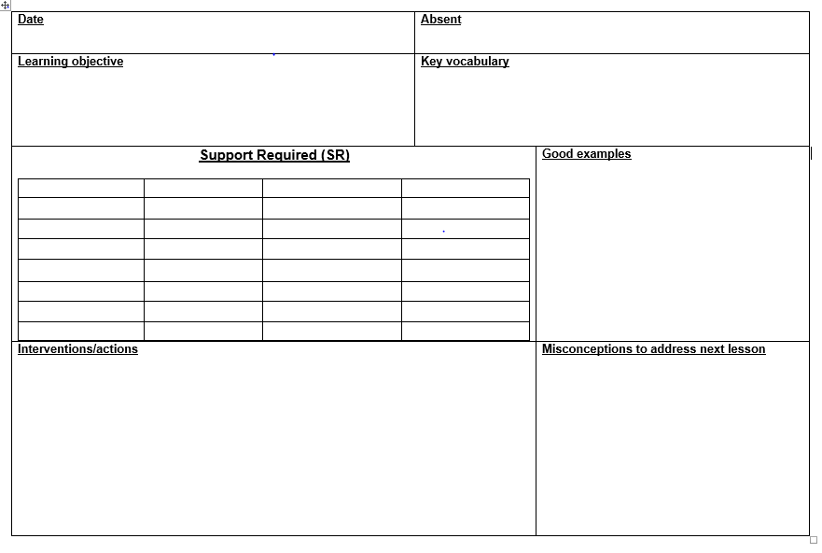
Appendix A Maths Feedback Sheet
Appendix B
